FATIMA JINNAH WOMEN UNIVERSITY

**Submitted by: Alishba Zainab**

**Roll no: 23-BSE-006**

**Semester: VA**

**Submitted to: Sir Waqas**

**ASSIGNMENT 1**

**CLOUD COMPUTING**

**Submission Checklist:**

1.Screenshot of your Gitea repository (showing README listing names & roll numbers)  
2.GitHub assignment 1 repo link (with README and large files)  
3.Screenshot or output of git remote -v showing both remotes

4.GitHub Pages link to your CV/portfolio

**Task 1: Run Gitea in Codespace and Create an Initial Repo**

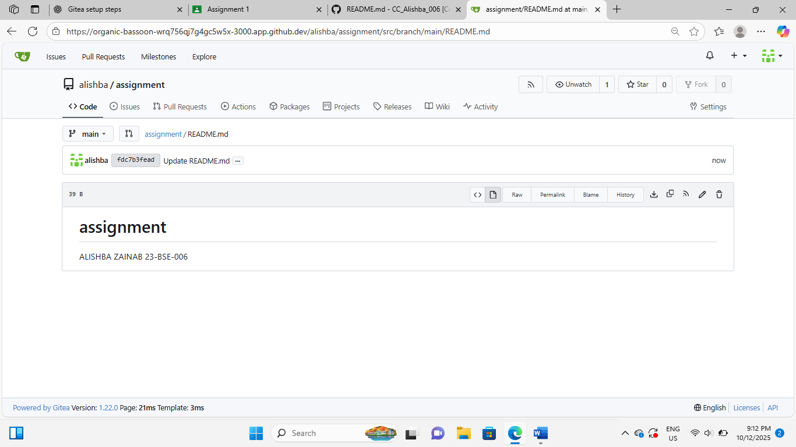

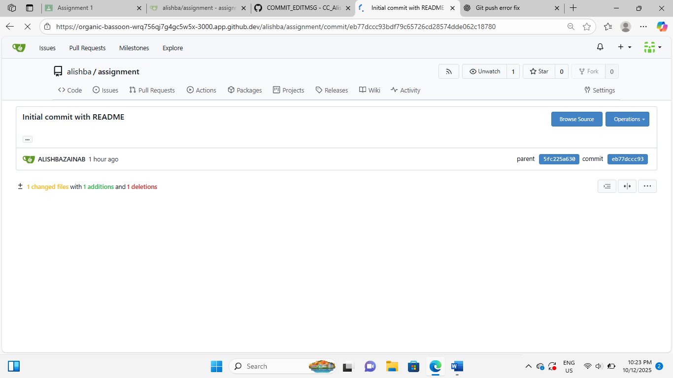

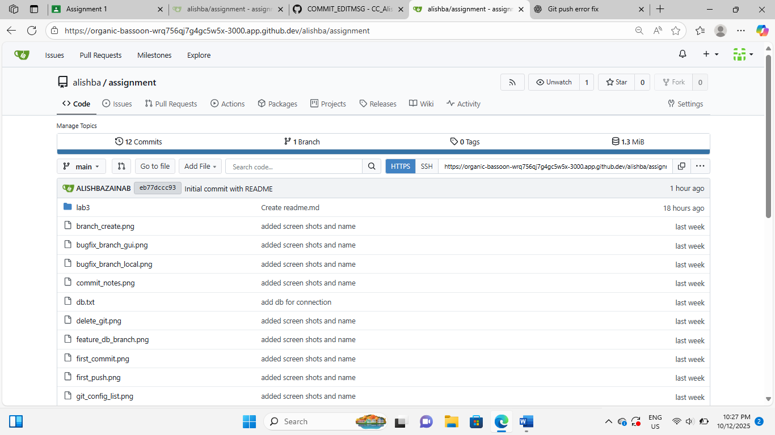

Task 2:

Mirror README.md from Gitea to GitHub

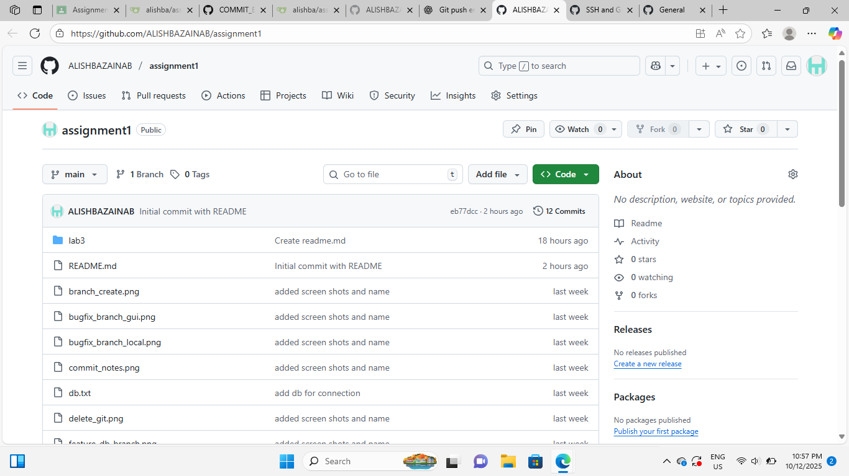

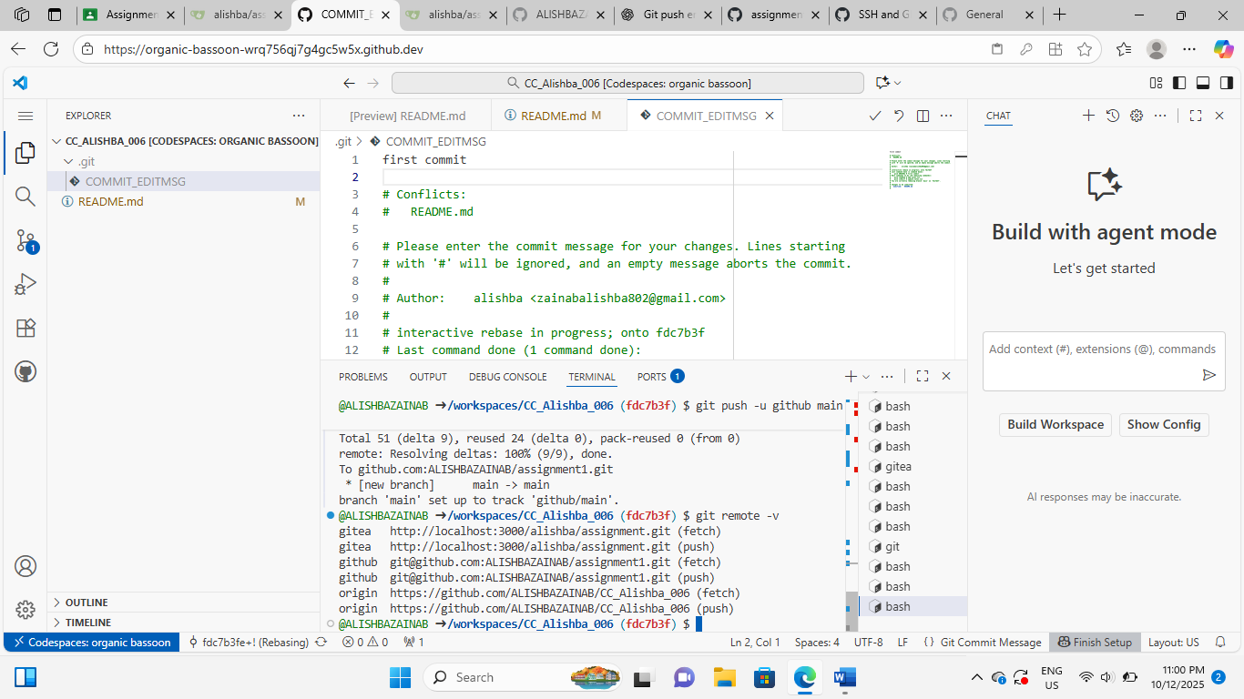

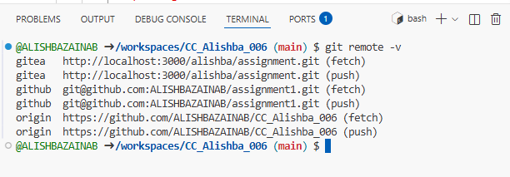

Assignment 1 repo link:

[ALISHBAZAINAB/assignment1](https://github.com/ALISHBAZAINAB/assignment1)

Task 3:

 Use Git LFS for Large Files

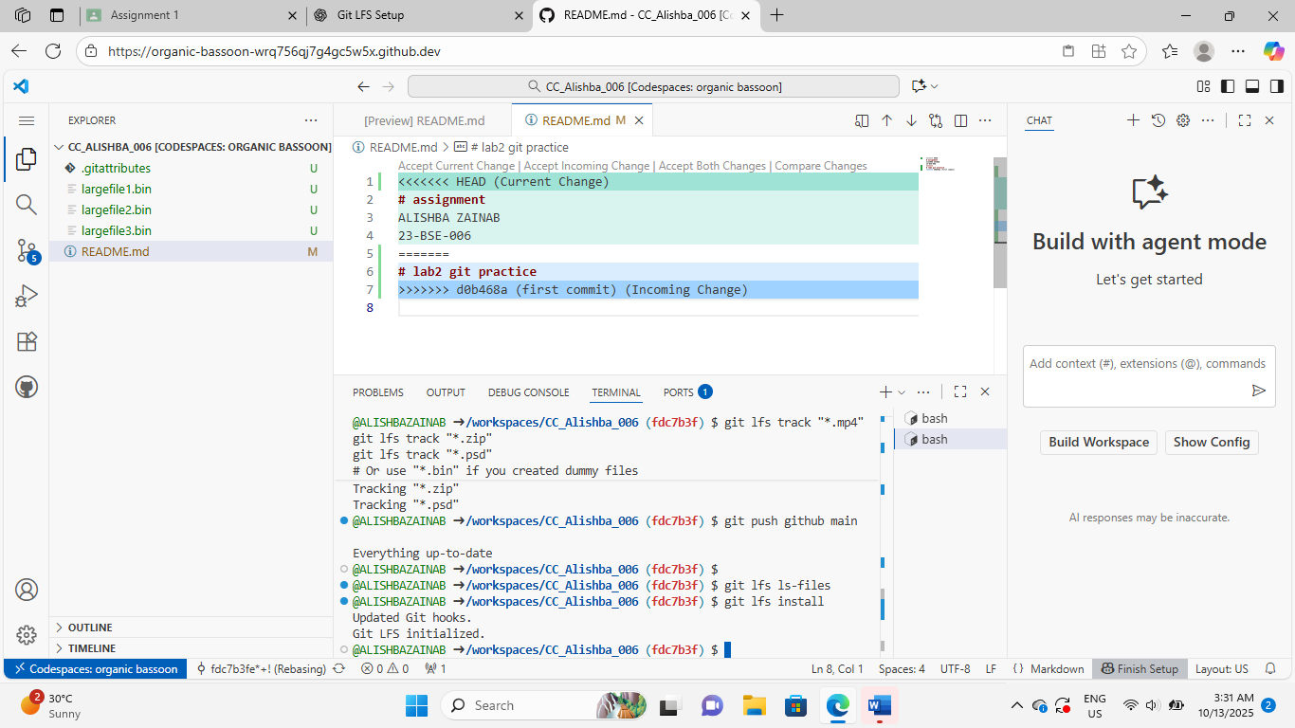

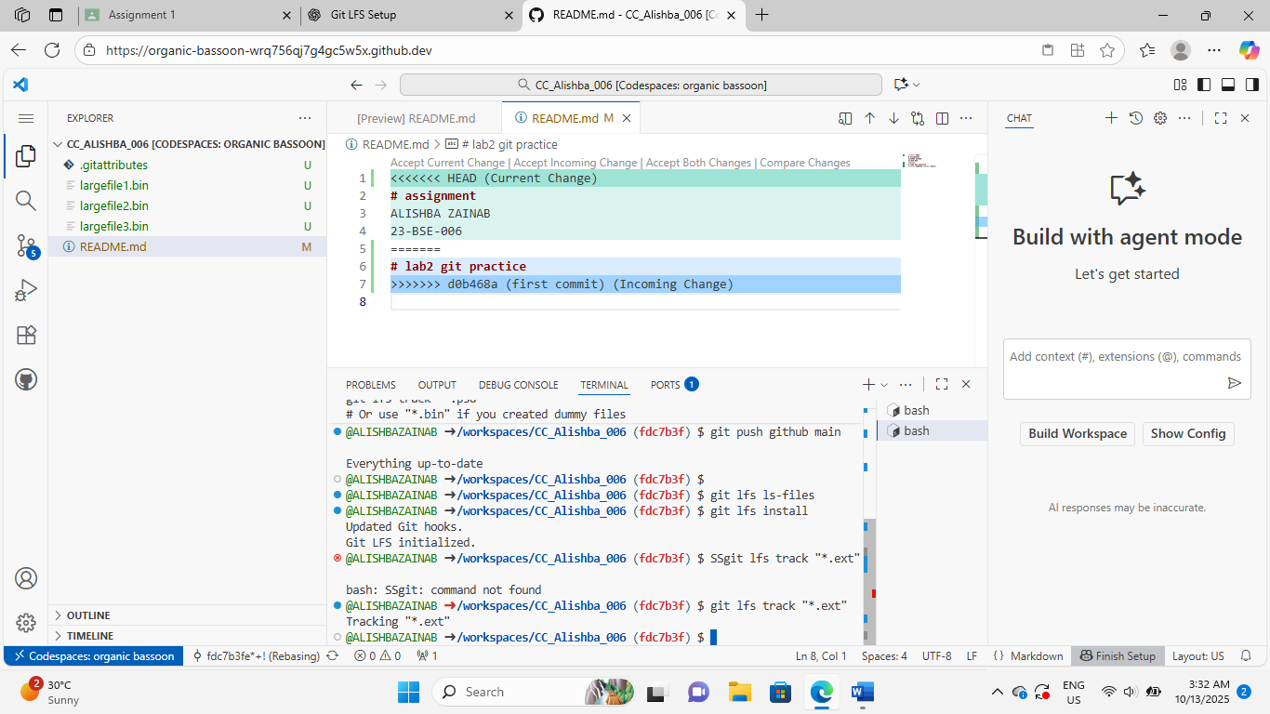

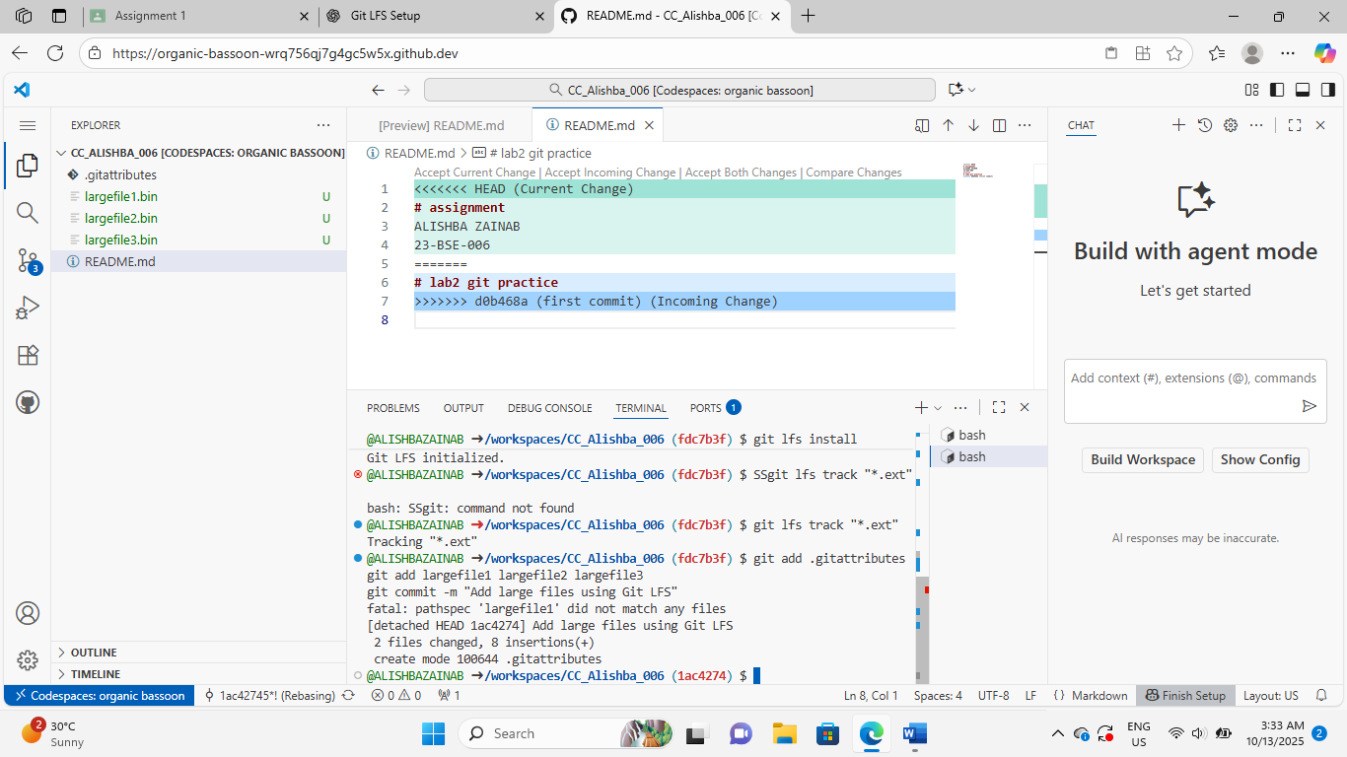

File tracked

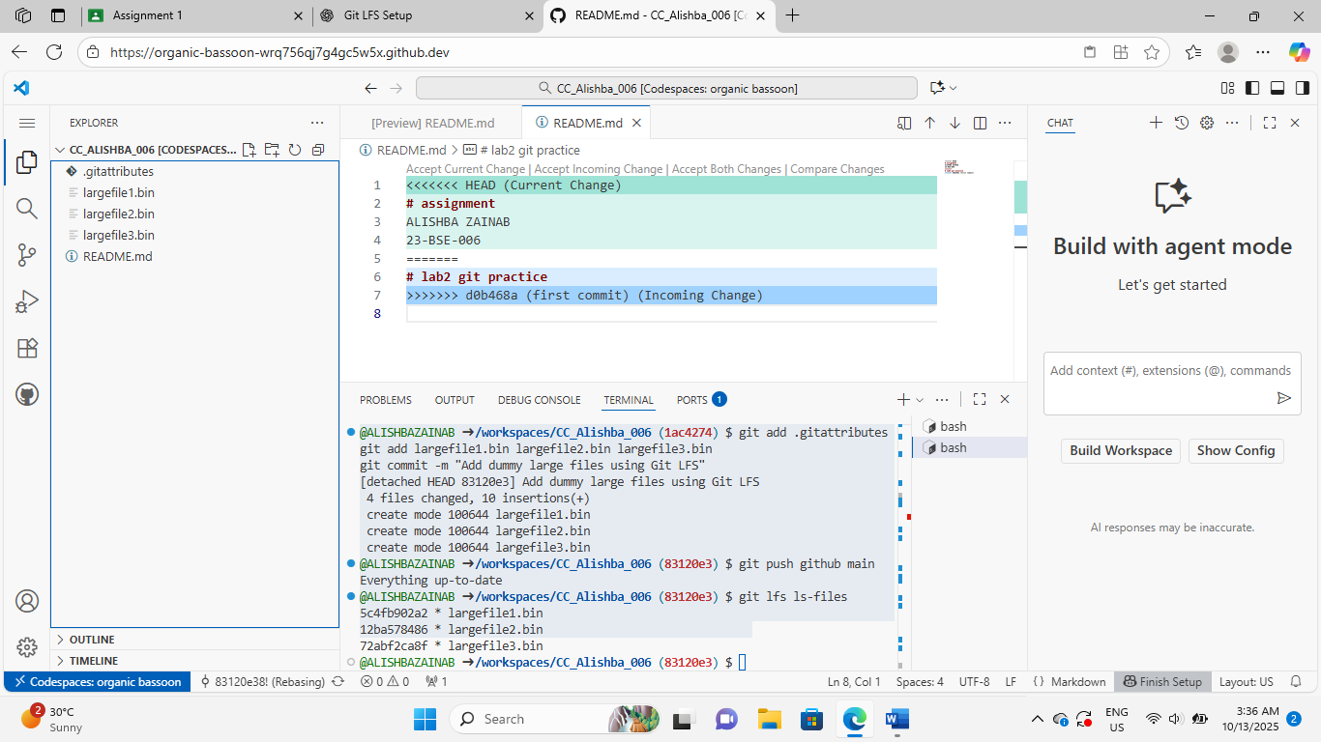

Files on github:

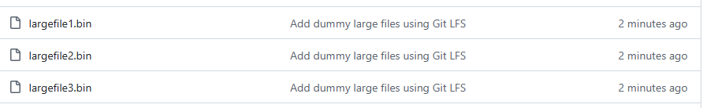

Task 4:

 Create a Portfolio/CV with GitHub Pages

[**https://alishbazainab.github.io/alishba.github.io/**](https://alishbazainab.github.io/alishba.github.io/)